The B.A.i.D List

A list of black Artists who are dancers, teachers, artistic directors,

choreographers, Writers, dance Academics, dance critics,

dance historians, producers, movement directors, Film Makers & programmers.

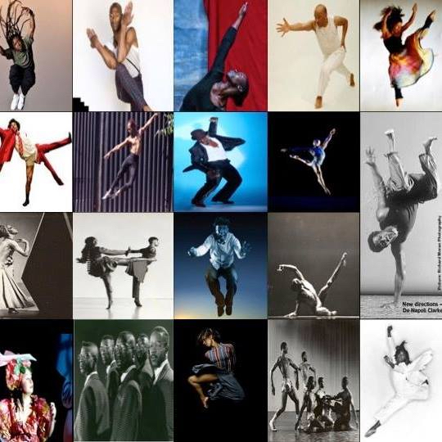

“Not everything that is faced can be changed,
but nothing can be changed until it is faced”.
James A. Baldwin

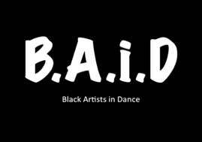

Aaron Chaplin

Abdul Shyllon

Adesola Akinleye

Adrian Falconer

Adriano Oliveira

Aida Diop

Aïsha Tenumah Jawando

AJ Cypher Cat

Ajani Johnson Goffe
Akeim Toussaint Buck

Akosua Boakye
Albie Olivierre

Alene Dunkley-Wood

Alesandra Seutin
Alex Lamptey

Alex Swerv Walker
Alexandrina Hemsley

Alfa Marks

Alsion Ray

Ama Rouge
Andile Sotiya

André Bright

Andrea Queens

Andrea Whiting

Andrew Lyle-Pinnock

Angela Andrews

Angela Marie Hurst

Anna Chiedza

Anna-Kay A Gayle

Annette Walker

Annie-Lunnette Deakin Foster

Anothy Matsena

Anthea Lewis

Antoine Marc

Anu Ogunmefun

April Milliner

Asha Jennings-Grant

Azara Rowena Meghie

Bakani Pick-Up

Ballet Black
Bawren Tavaziva

Ben Love

Benji Reid
Beverley Glean

Bismark Anobah

Bob Ramdarnine

Bolaji Badejo
Brandon Sears

Brenda Edwards

Briony Scarlett

Callum Israel Sterling

Carl Campbell

Carl Parris

Carla Trim-Vamben Holtz

Carlos Martinez

Caramel Soldier

Carol Straker

Carolene Hinds

Caroline Mulrado

Cathy Lewis

Carolyn Lilly

Cavin Cornwall

Chaldon Williams

Chloe Gregg

Chris Gordon

Chris Radford

Christopher Tendai

Cira Robinson

Claud Paul Henry

Colin Poole

Colin Sinclair
Coral Messam

Corey Mitchell

Cori D Billy

Corrine Bougaard

Courtney Jackson
Curtis James

Dalh Haynes
Damarys Farres

Daminan Winter-Higgins

Dan Martin

Dani Harris-Walters
Daniel Adegboyega Williams

Daniella May

Darren Panton

Darren Pitchard

David Blake

David Eward Nurse

David Hamilton

David Olton
Dawn Holgate

Deborah Baddoo

Delene Gordon

Dennis A Alexander
Denzil Bailey

Denzil Beezmore

Derya Donaldson

Dessy Adesuwa

Diane Alison-Mitchell

Dickson Bruv
Dollie Henry

Dominic Spin

Dominic-Lawrence Smith
Donald Edward

Donna Berlin
Douglas Thorpe

Duane Kitaka

Duwane Taylor

Dwight Powell

Earl-Lloyd Hepburn

Ella Jade

Ellen Miller

Elsabet Yonas

Emmanuella Idris

Esme Benjamin

Femi Taylor

Frank Wilson

Ffion Campbell-Davies

Francis Angol

Frankie Jplague Full

Freddie Opoku-Addaie

Frederick Folkes

Fumy Gop
Funmi Adewole

Gail Parmel

Gary Benjamin

Gary Nurse

Gemma Weekes

Gerrard Martin

Godiva Marshall

Goran Gbo

Grace Okereke

Graham Nelson-Williams

Greta Mendez

Hakeem Onibudo

Hanna Meraki

Hannah-Ruth Moore
H-Patten

Habibat Ajayi

Heather Benson

Helena Boyce

Henri Oguike

Hopal Elaine Romans

Hughie Donagan

Ian Parmel

Imani Jendai
Ingrid MacKinnon

Ira Mandela Siobhan

Iris De Brito Full

Irven Lewis

Isaac Baptiste

Isaac Ouro-Gnao

Ivan Blackstock
Jackie Guy

Jacqui Boatswain

Jade Hackett

Jake Nwogu

Joelle Dyson

Jahmarley Bachelor

Jamaal Burkmar

Jason Alexander Cameron

Jason Pennycooke

Jean Abreu

Jeanefer Jean Charles

Jerry IDJ

Jessica K L Holder

Jevan Howard-Jones
Joanne Bernard

Jocelyn Prah

Joelle Dyson

John leader

Johnny Amobi

Jonathan Reid
Jonzi D Aggylev

Jordan Ajadi

Joshua Robinson

Joseph James Mutebi Poulton

Joseph Yvan Toonga

Joyce Gyimah

Jreena Green

Judith Palmer

Julie Felix

Juliet Ellis

Juliet Vibert

Junior Laniyan

Kamara Gray

Kayla Lomas-Kirton

Keeley Dann

Keith Hodiak

Keiran Donovan

Keisha Grant

Kelechi Nwanokwu

Kemi Durosinmi
Kendrick Sandy

Kennedy Junior Muntanga

Kenneth Olumuyiwa Tharp

Keron Mikey Proverbs

Kevin Turner

Kieran Warner
Kiraly Saint Claire

Kirk Patterson

Kloe Dean

Kofi Mingo

Kristina Alleyne

Kwame Lacious
Kwesi Johnson

Kymberlee Jay

Laila Diallo

Lanre Malaolu

Layton Wiliams

Leanne Pero

Lee Payne

Leon Hazelwood

Leon Maurice-Jones

Leon Robinson

Leonora Stapleton
Lewis Anthony Bramble

Liam Francis
Lisa Anderson
Lorraine Leblanc

Louis Parker-Evans

Louise Katerega

Luanda Paustyle

Lucy Banfield

Lucy St. Louis

Lukas Hunt

Mactaly Nyamusole

Malachi Spalding

Marcia Edwards

Maria Ghournrassi

Maria Ryan
Mark Elie

Mark Hindle

Martin Hylton

Martin Robinson

Martina Gumbs

Matthew Sandiford

Maxine Anthony

Mayowa Ogunnaike

Mbulelo Ndabeni

Melanie Joseph

Melanie Teall

Melissa Rose Gumbs

Melvin LeBlanc

Mercy Nabirye

Michael Burgess

Michael Glasgow
Michael Joseph

Michael Moor

Michael Noble

Michael Small

Michelle Ballentyne
Miguel Altunaja

Mikey J. Asante

Mikloth Bond

Mina Aidoo

Miriam-Teak Lee

Moses Ward

Muti Musafiri

Mykal Rand

Nadia Gardner

Nahum Mclean

Namron

Nandi Bhebhe

Naomi Czuba

Natasha Cox

Natasha Gooden

Nathan Geering

Nathan Johnston

Neil Johnson

Nejla Y. Yatkins

Nicholas Norman

Noel Wallace
Norman Stephenson (Rubba)

O’neil Rochester

Ofelia Omoyele Balogun

Omar Kidd Ronin Spence

Omar Okai

Omari Carter

Omari Swanston-Jeffers

Onyemachi Ejimofor

Owen Ridley-Monick

Paaliba Abugre

Pamela Johnson

Para Digumz

Paris Crossley
Patience Gop
Eddie Boakye

Patrick Lewis

Paul Bailey

Paul Hazel

Paul Henry
Paul Liburd

Pearl Jordon

Perry Louis

Peter Badejo

Prince Morgan

Rachael Alleyne

Rachael Nanyonjo

Raymond Wilkes
Razak Osman

Renako McDonald

Rhys Dennis

Ria Uttridge

Ricardo Dasilva

Richard Lloyd-King

Richard Myeski

Richard Pitt

Rjc dance

Robert Hylton

Ronke Fadare

Rowdy Yami

Rudzani K Moleya

Ryan & Gilly (Prospects Fraternity)

Ryan Toussaint

Sadé Alleyne

Salome Pressac-Hewitt

Samantha Haynes

Sandie Bourne

Sandra Golding
Sara Dos Santos

Sarah Golding
Sarita Spires
Sean Graham
Seke Chimutengwende

Selene Thomas

Shanelle Clemenson

Shannelle Fergus

Shaq Taylor
Sharon M Watson

Sharon Rose

Shawn Addison
Shawn Williams

Sheliane Prince

Shelley Maxwell

Sheralee Ferguson

Sheron Ama Wray
Sherinne Kayra
Anderson

Shevelle Denotte

Sia Happy Heart Gbamoi

Sia Kpakiwa

Sim CampbellI

Simeon Montague

Simeon Qsyea

Simon Champagnie

Simone Foster

Simone Mistry-Palmer

Sonia Swaby

Sophie Apollonia

Stewart Arnold

Stuart Thomas

Stuart Thomas (London)

Syxx Isaac
T Damien Anyasi
Talisha Thomas-Lindsay

Tamar Dixon

Tanya Anderson

Temujin Gill

Theo Godson Oloyade
Theophilous Alade

Tim Hamilton

Tony James-Andersson

Troy Banton

Tyrone Isaac-Stuart
Valerie Ebuwa
Valerie Zainab Jah

Verona Patterson Idc
Vicki Uchenna Igbokwe

Victoria Shulungu

Vincent Hantam

Vivian Gayle

Waddah Sinada

Wanjiru Gichigi

Wild G

Yassmin V Foster

Zinzi Minott

